MENS NECKLACE SIZE CHART

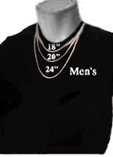 | 18" Fit at the base of the neck, for small neck sizes  20" Falls at the collarbone. The most common length for men  24" Falls just above the sternum

