WOMENS NECKLACE SIZE CHART
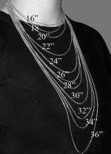 | 16"--Fit like a Choker  18"--Falls at the collarbone  20"--Falls few inches below collarbone  A 16 inch necklace falls perfectly around the base of the neck and fits like a choker. For petite frames, a 16- inch necklace might hang slightly lower up to your collarbones. Most necklaces come in 16 inch length and a simple necklace or a choker will complement almost any outfits and any necklines.  An 18 inch necklace, as the more popular choice among women, will fall just below the throat at the collarbone. This type of necklace will complement low plunging, deep V necklines and if you add a bold pendant, it will give a nice contrast to your outfit. For plus size women, this necklace might feel like a choker.  A 20 inch necklace will fall few inches below the collarbone and will allow a little more breathing room. Some women preferred this long necklace to be worn as a complement for business or casual dress. This type of length will also be a perfect choice for turtlenecks or cowl necks.

